# Deployment on Azure PaaS

## Deployment of Front-end using Visual Studio Code:

Step 1: Go to Azure Portal and Click on Create a Resource, it will redirect you to azure Marketplace.

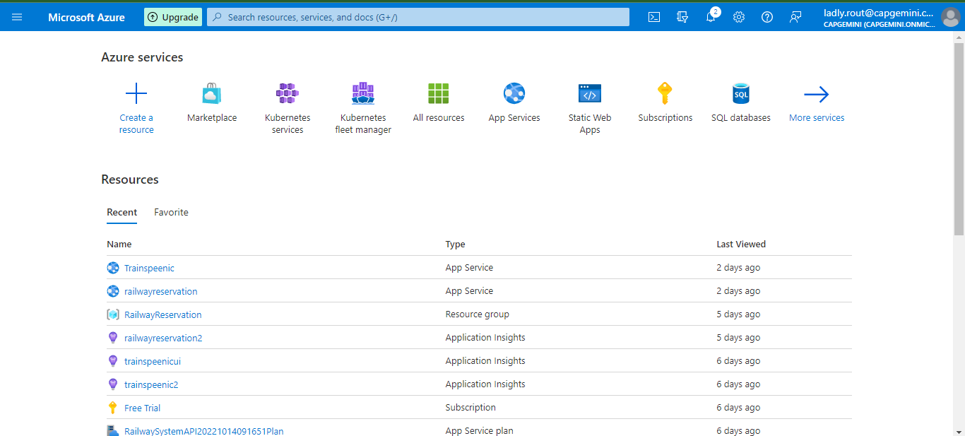

Step 2: Search for Web Apps in the search bar.

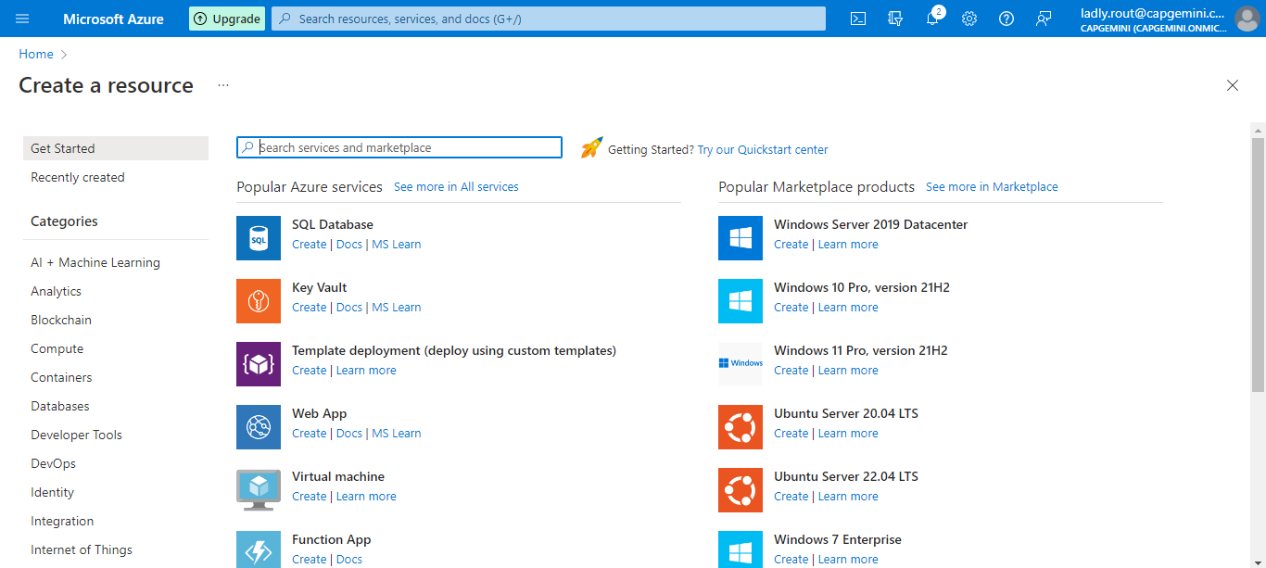

Step 3: Click on Create

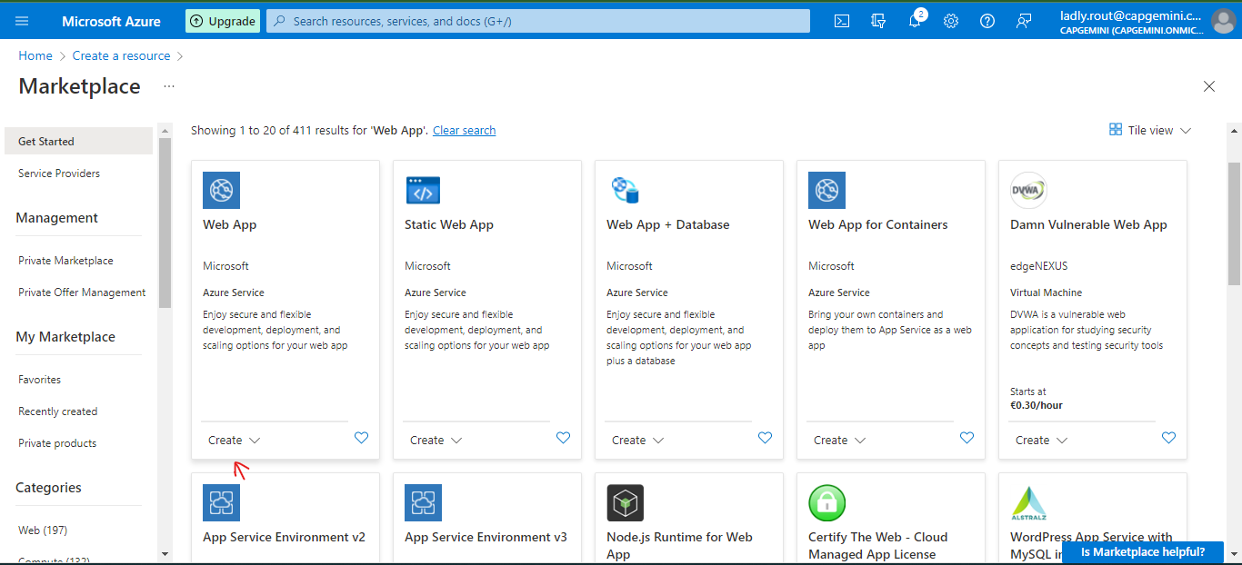

Step 4: Select your Subscription type and Resource Group from the drop down.

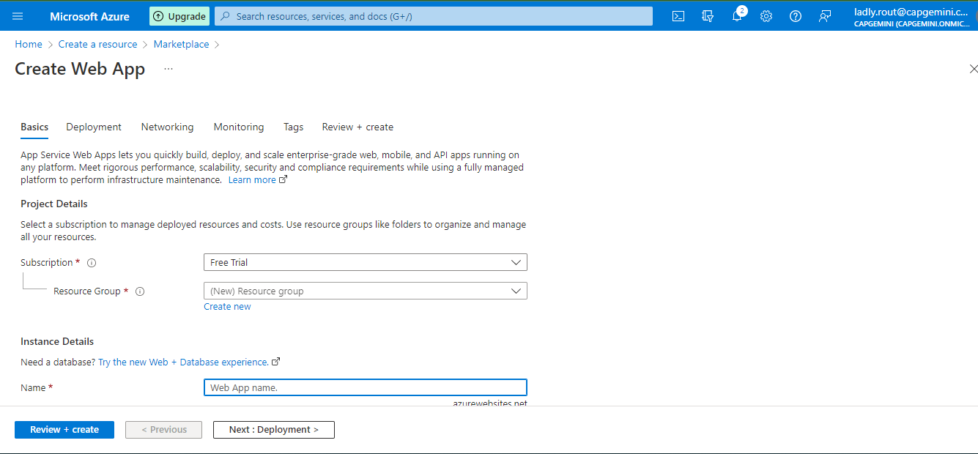

Step 5: Write a name, select a runtime stack (It should match with your node version, so do check your node version in CLI by writing node –version), and select a region.

Step 6: Select your Hosting Plan and the size. After that you can Click on “Review+Create”.

Step 7: Click on Create.

Step 7: Go to Resource.

Step 8: Copy the URL and paste this link to your Backend project CORS.

Step 9: Save it.

Now that your Resource is created go to your Visual Studio Code and open your Project Folder.

Step 10: Do Change your APIURL in frontend.

Step 11: Open Terminal or CLI in your local machine and write the command

**ng build –prod**

Now your project is up to date.

Step 12: Now in your VSC (Visual Studio Code), click on extensions And search for azure app services, install it.

Step 13: Now you’ll have an azure icon, select it, click on App Services.

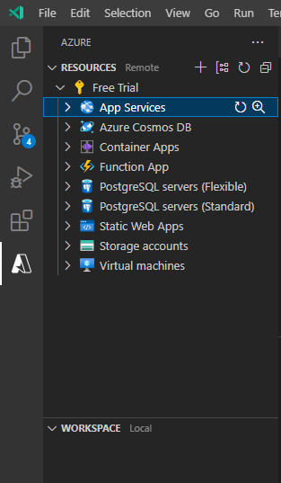

Step 14: In the dropdown you’ll be able to see all the app services you’ve created. Click on the app service you’ve just created. Right click on it and you’ll get a drop down. Click on Deploy to web app.

Step 15: Click on Browse



Step 16: Select the dist folder and upload the folder inside it.

Step 17: You’ll get a warning, click on deploy. It’ll take a few minutes.

Step 18:Now your App is Ready.